IST 687: APPLIED DATA SCIENCE

Final Project Report

Instructors: Jeffrey Saltz; Gary Krudys

Team Members:

Sharat Sripada

TABLE of CONTENTS

Introduction

Business Questions

Methodology

Importing the data, cleansing, munging and preparation

Initial analysis

Descriptive statistics

First cut of analysis

Visualizations

Summary of the initial analysis

Data Modeling Techniques and Predictive Analysis

Linear Regression

Detailed Analysis

Support Vector Machines (SVM)

KSVM model

SVM model

Conclusion

Actionable Insights

# 

# Introduction

The final report was prepared solely by Sharat Sripada, a student of course IST-687 taught by Professor Gary Krudys during the timeframe Jan-Mar 2020.

The initial dataset that was provided was 16MB in size & mostly comprised data pertinent to Airline Passengers, their preferences in Airlines, routes, satisfaction etc. The goal was to be able interpret the data-set using advanced concepts of statistics and the R programming language gained during the course of study.

# Business Questions

The intent when analyzing the airline booking data-set was to represent an airline and play the role of a Business Analyst or Consultant with specific function of Data-Scientist. In this context, I decided to represent *Southeast Airlines Co.* since from initial analysis it became evident that they were not the most preferred airline and that therefore would offer sufficient challenge and scope to analyze and make or show improvements.

What I am attempting to do with my analysis is:

1. Determine commonly top/worst performing airlines in the segment
2. Key factors or variables likely to impact passenger sentiment, airline bookings etc.
3. Using advanced prediction techniques provide consulting suggestions

# Methodology

## Importing the data, cleansing, munging and preparation

* Import the data using read-xls function of R
* Omit NAs for descriptive statistics
* Identifying variables that would aid the analysis

After spending hours analyzing the data decided to review the data-set with respect to the following specific variables:

|  |  |  |
| --- | --- | --- |
| **SL** | **Variable Name** | **Meaning** |
| 1 | Satisfaction | It is rated from 1 to 5, that how satisfied is the customer?   1. 5 means higher satisfied, and 1 is lowest level of satisfaction. |
| 3 | Arrival Delay in Minutes | How many minutes of arrival delayed of each passenger. Rang of delayed minutes in this data are starting from 0 until 1115 minutes. |
| 4 | No. of other Loyalty Cards | It is kind of membership card of each customer, that for retail establishment to gain a benefit such as, discounts. |
| 5 | Airline Name | There are several airlines company names such as, West Airways, Southeast Airlines Co, and FlyToSun Airlines Inc. This attribute provides what airline name that passenger have been used. |
| 6 | Type of Travel | is provide three traveling purpose for each consumer, which are business travel, mileage tickets that based on loyalty card, and personal travel like to see the family or in vacation |
| 7 | Airline Status | Each customer has a different type of airline status or package, which are platinum, gold, silver, and blue. |
| 8 | Price Sensitivity | The grade to which the price affects to customers purchasing. The price sensitivity has a range from 0 to |
| 9 | Airline Status | Each customer has a different type of airline status or package, which are platinum, gold, silver, and blue. |

* Recoding some of the variables to be able to use for predictive analysis

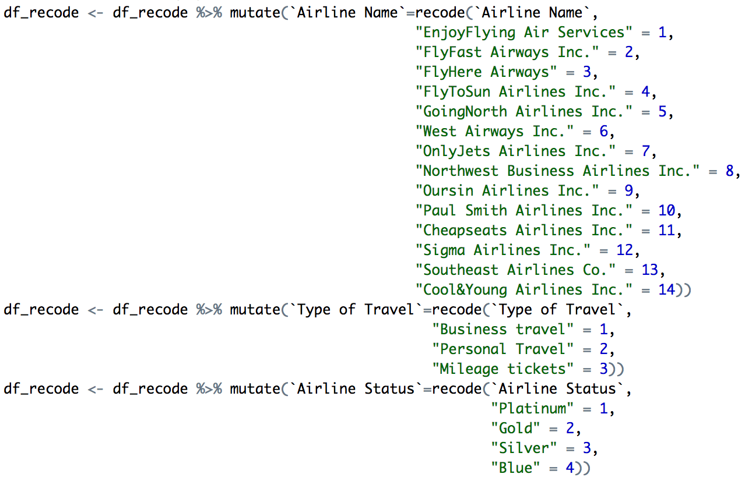

## Initial analysis

Initial analysis was based on determining key factors effecting passenger sentiment, highest/lowest booking etc.

### Descriptive statistics

Predominantly, used the mean() function in R skipping NA values where applicable when determining parameters related to delays, satisfaction and other factors

### First cut of analysis

Below are outputs of functions implemented to provide conclusive data regarding variables that seem obvious:

* Classify airlines in terms of delay (arrival/departure)

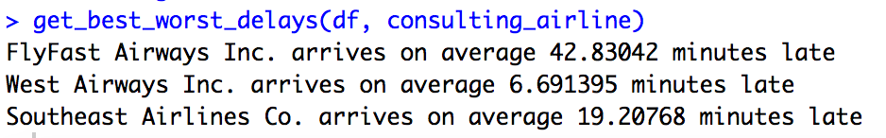

* Based on the booking volumes determine most/least popular airlines

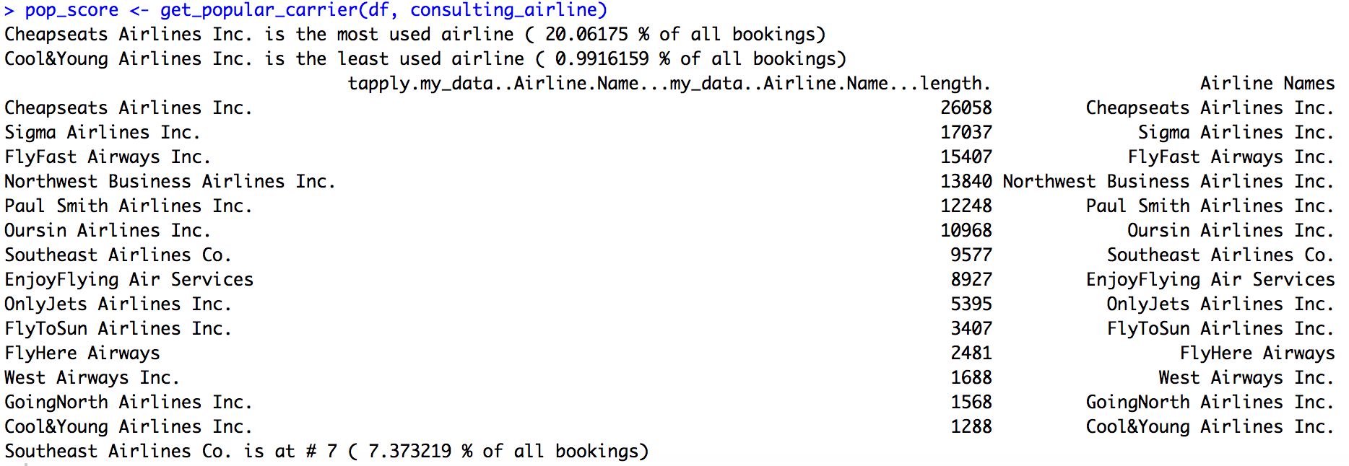

* Determine the mean satisfaction score per airline

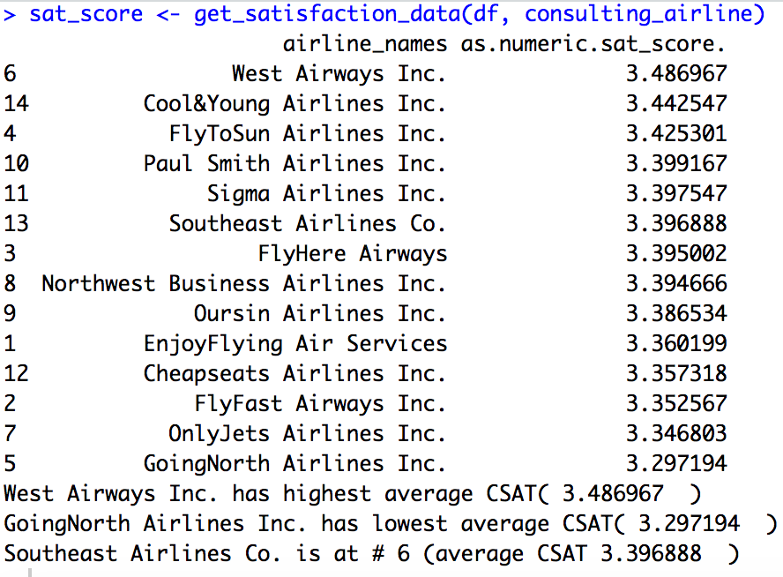

* Total number of loyalty cards offered per airline

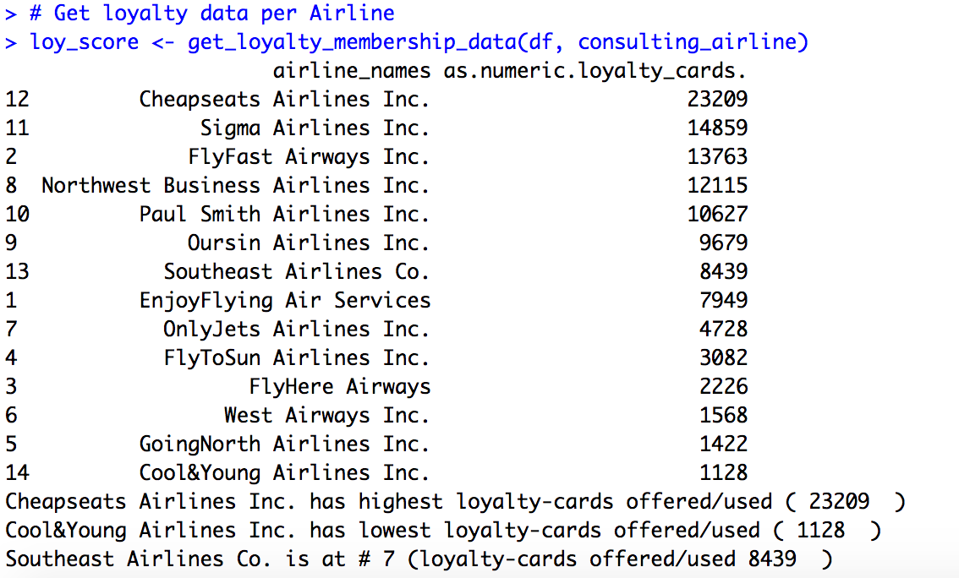

### Visualizations

Visual techniques helped to ascertain correlation between variables. Below for instance is a histogram plot of variable ‘Satisfaction’ for passengers by variable ‘Airline Name’ type



Sat

#6

Pop

#7



Sat

#4

Sat

#5

Pop#5

Pop#2



Pop#3

Sat

#8

Pop#4

Sat

#12

The visualization helped ascertain that the Satisfaction variable largely had little bearing on how popular an airline with respect to passenger booking.

### Summary of the initial analysis

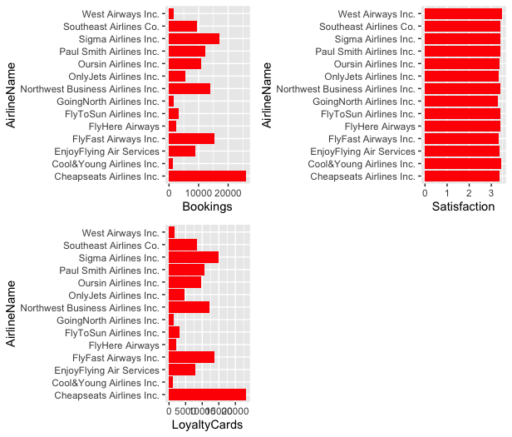

Hence, derive the following intermediate or visual conclusion:

* Delay & Popularity of airline - **WEAK**
* Satisfaction & Popularity of airline - **WEAK**
* Loyalty cards & Popularity of airline - **STRONG**
* Delay & Satisfaction – **MEDIUM**

# Data Modeling Techniques and Predictive Analysis

## Linear Regression

Based on the initial analysis we now move to corroborate intermediate conclusions with known techniques or methodologies related to Linear Regression modeling. Since the model is highly efficient and automated there is scope to expand the number of variables.

Following are some of the variables from the data-set that have been identified:

* Arrival Delay in minutes
* Departure Delay in minutes
* Satisfaction
* No. of other Loyalty cards
* Airline Names
* Airline Status
* Type of Travel
* Price Sensitivity

### Detailed Analysis

#### Correlation between Airline Name & No. of other Loyalty cards

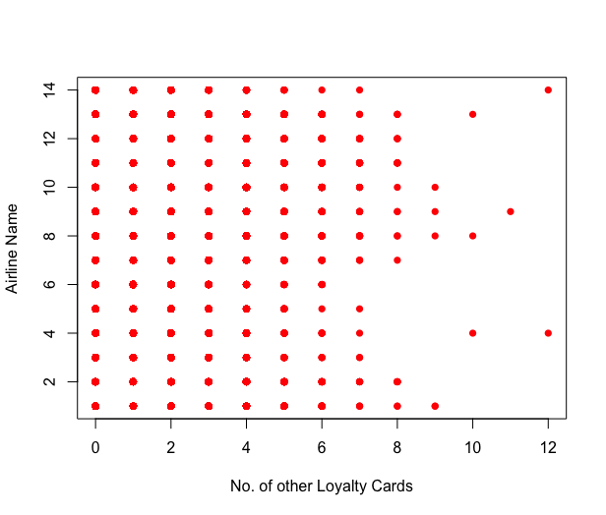

Here’s the corresponding statistical analysis/R-square value:

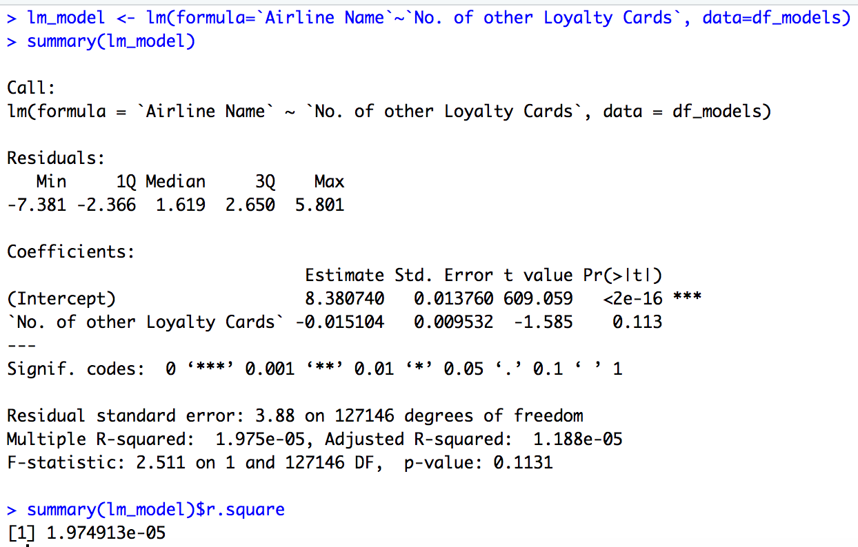

**Conclusion-1**

Low R-square values indicates low correlation & we are therefore unable to reject the NULL hypotheses – ‘No correlation exists between Airline Names and No. of other Loyalty Cards.

#### Correlation between some of the other variables

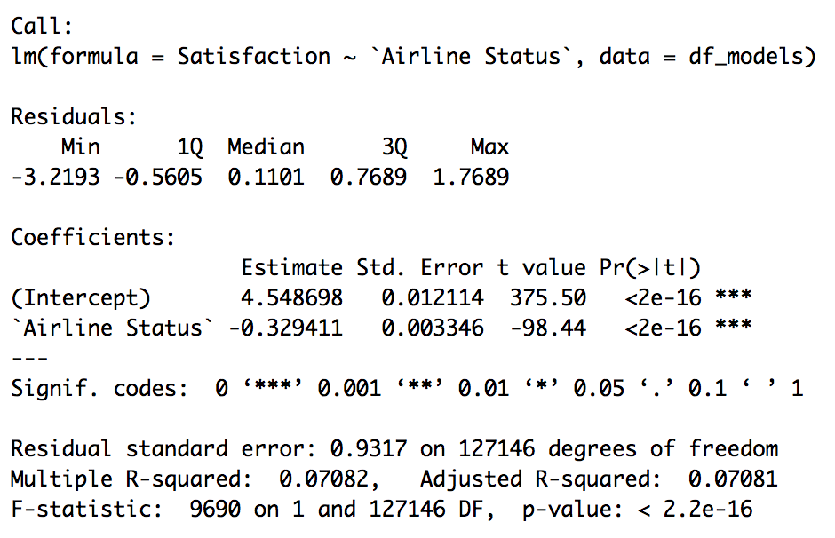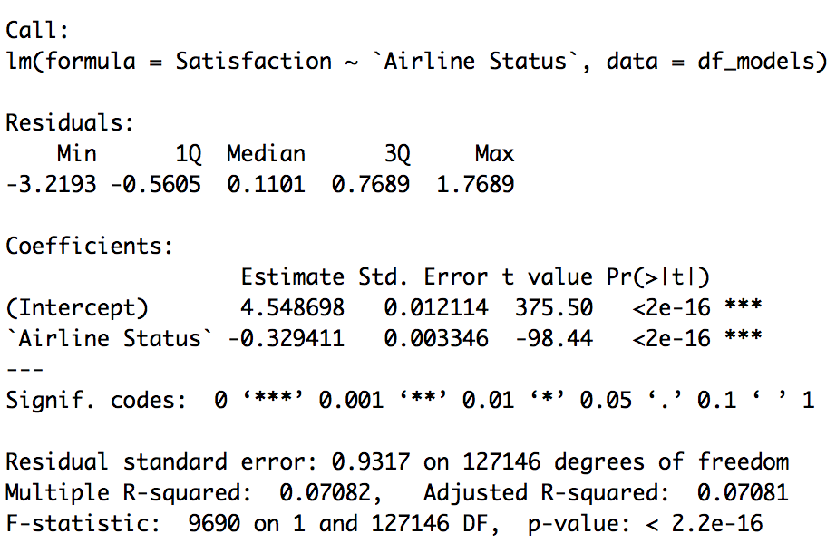

**Conclusion-2**

Low R-square values/correlation co-efficient between several combination of variables

#### Parsimonious Model/step-function

Created the following data-frame considering all possible variables and ran a step() function so we could the Parsimonius Model to help determine the least possible number of variables that can predict Airline Name

Here’s the code excerpt & the corresponding result of the step() function:

colnames(df_models) <- c("Airline Name",

"Satisfaction",

"No. of other Loyalty Cards",

"Departure Delay in Minutes",

"Arrival Delay in Minutes",

"Price Sensitivity",

"Type of Travel",

"Airline Status")

.

.

lm_model <- lm(formula=`Airline Name`~., data=df_models)

step(lm_model, data=df_models, direction="backward")

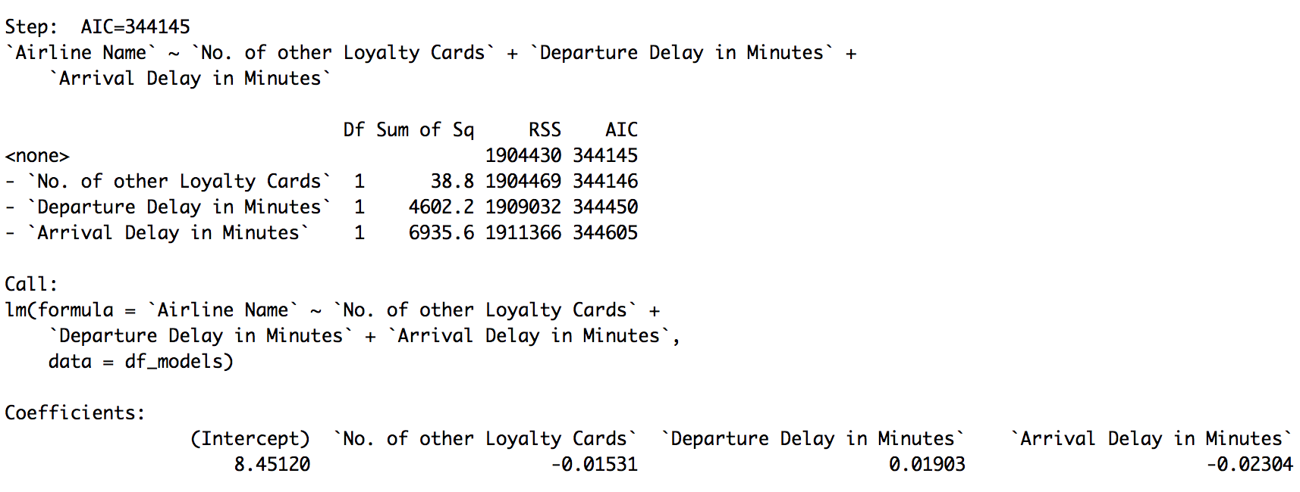

#### Predictive Analysis

Ran the predictive analysis using Linear regression, factoring in results from Parsimonius model

* All variables shortlisted thus far

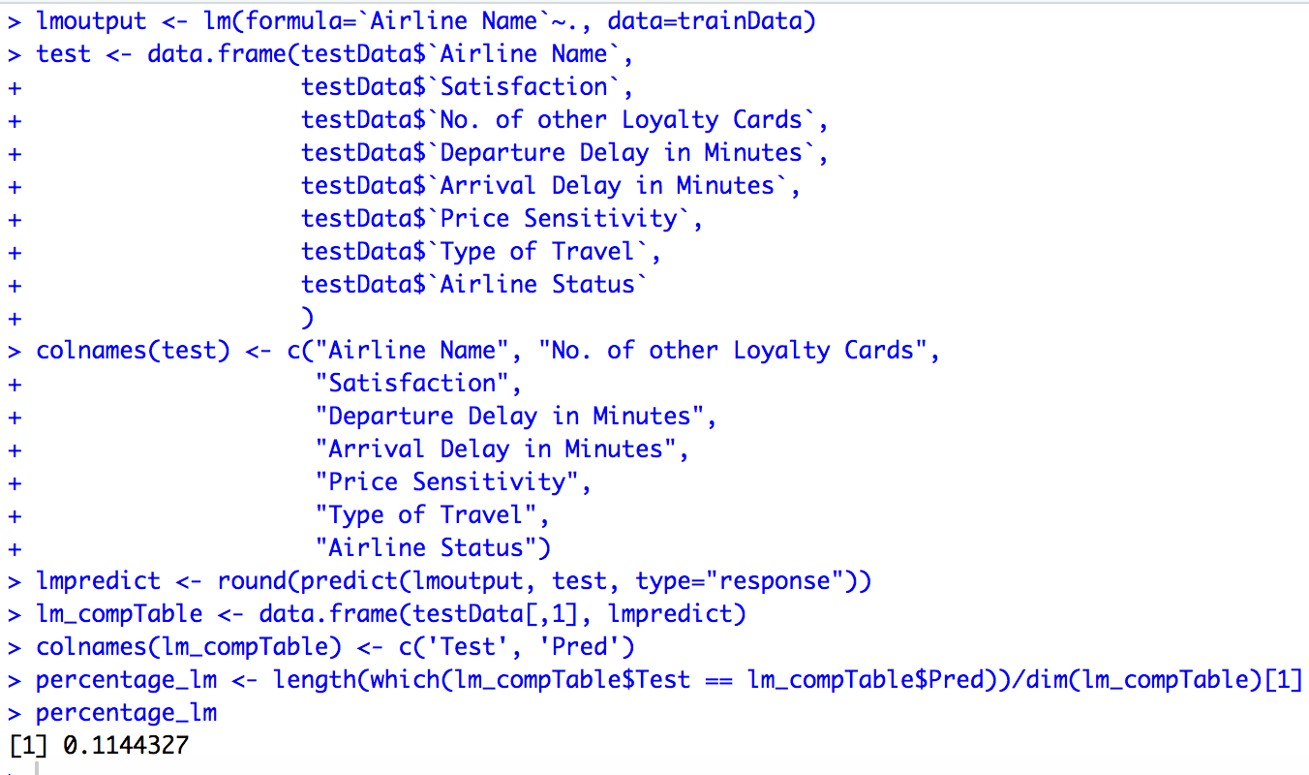

* Variables as a result of Parsimonius Model/Step function did not yield very useful prediction as well at 11.48%

**NOTE**

Since the variable ‘Airline Name’ was recoded from text/chr to a numeric it was important to determine the absolute prediction than a Root Mean Square Error (RMSE). RMSE itself was low at ~3, but in this context is not relevant.

## Support Vector Machines (SVM)

The linear regression model proved to be not successful with predicting variable ‘Airline Names’ from a set of variables likely to have causation. We now move to exploring the data-set using techniques or algorithms outlined in support vector machines.

### KSVM model

Below is code excerpt using KSVM model

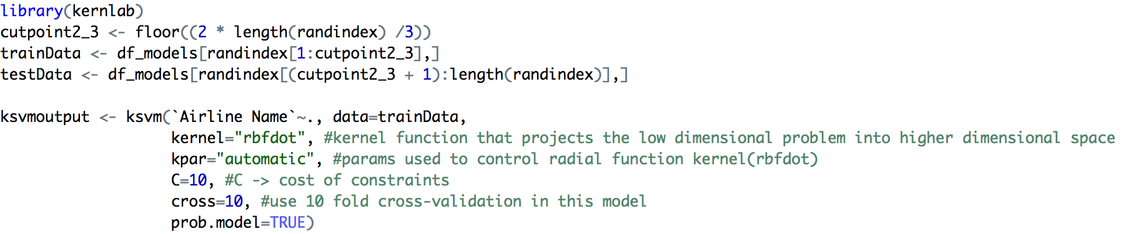

Using this prediction accuracy was at 11.74%:

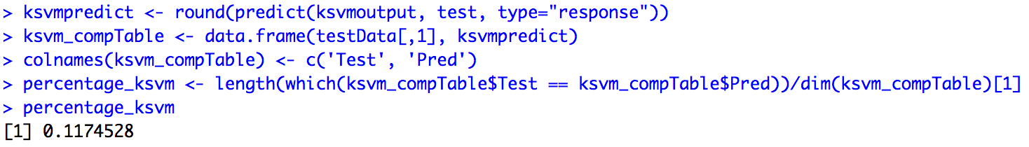

### SVM model

Finally, ran the SVM linear model that yielded similar results of accuracy as well. Below is the code:

library(e1071)

svmoutput <- svm(`Airline Name`~., data=trainData,

kernel="linear", #kernel function that projects the low dimensional problem into higher dimensional space

cross=10, #use 10 fold cross-validation in this model

scale=FALSE)

svmpredict <- round(predict(svmoutput, test, type="response"))

svm_compTable <- data.frame(testData[,1], svmpredict)

colnames(svm_compTable) <- c('Test', 'Pred')

percentage_svm <- length(which(svm_compTable$Test == svm_compTable$Pred))/dim(svm_compTable)[1]

**NOTE**

Both the SVM and KSVM models take several hours to complete on the large dataset owing to complex underlying computations. Some of the outputs may therefore not be available here.

## Conclusion

Neither the linear nor KSVM/SVM models were accurate in predicting the Airlines that passengers were likely to book based on the filtered data that seemed likely to influence passengers.

Ideally, in use-cases related to human behavior a prediction accuracy of 30% is recommended however, we see a far lower number. Given this, I would use KSVM model with a slightly better prediction rate for all analysis further.

# Actionable Insights

From analysis earlier passengers offered with Loyalty cards or rewards (may include discounts etc.) preferred a certain Airline/carrier. Below is the summary of that analysis where Cheapseats Airline Inc, had the highest passenger bookings and had also offered the highest number of loyalty cards:

* Cheapseats Airlines Inc. has highest loyalty-cards offered/used (23209)
* Cool&Young Airlines Inc. has lowest loyalty-cards offered/used (1128)

*Southeast Airlines Co*. is at # 7 (loyalty-cards offered/used 8439 )

Based on the above & as an experiment, ‘No. of loyalty cards’ variable was adjusted in the following manner for SouthEast Airlines Co.:

* If no cards were offered, offer one card at the least
* If cards were already offered then increase the number of loyalty cards by 10%, 50% and 100%

df_models_order <- df_models[order(df_models$`Airline Name`),]

rownames(df_models_order) <- NULL

df_models_my_airline <- df_models_order[df_models_order$`Airline Name` == 13,]

start_row <- as.numeric(rownames(df_models_my_airline)[1])

end_row <- start_row + nrow(df_models_my_airline) - 1

for (i in c(start_row:end_row)){

if (df_models_order[i,3] == 0){

df_models_order[i,3] <- 1

} else {

df_models_order[i,3] <- ceiling(df_models_order[i,3] * 2.0)

}

}

Now, using the KSVM model following are the results of bookings of Southeast Airlines Co. as a direction prediction of increase in loyalty cards:

|  |  |  |
| --- | --- | --- |
| **Percentage increase in loyalty cards offered** | **Bookings per data set**  **(in numbers)** | **Bookings per data set**  **(in %)** |
| 10% | 294 | 3.9% |
| 50% | 889 | 11.88% |
| 100% | 414 | 5.53% |

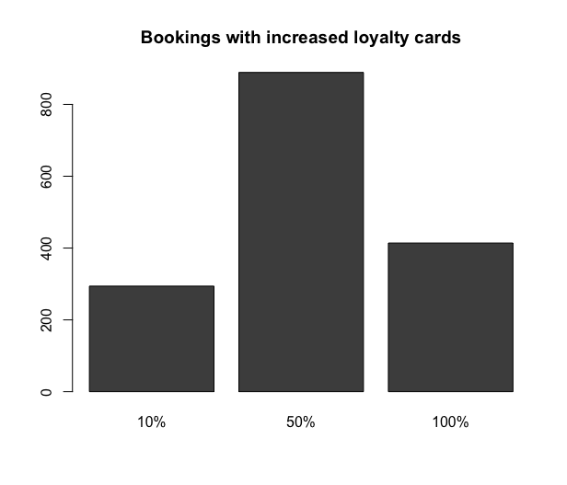

Clearly in my opinion variable ‘No. of Loyalty cards’ seems a mere distractor and cannot be used in any meaningful analysis. Also, that statement possibly holds some ground to the dataset in entirety. As a Data-Scientist or Business Analyst for Southeast Airlines Co. I would recommend getting more insightful data:

* Adding passenger first and last names can possibly help in determining how a passenger truly rated his/her experience when flying an airline provider and how that impacted flying again with the same airline in the future
* Specific satisfaction indices – related to delay and service

# Appendix

Following is all the code that was written in the R programming language for the purpose of analyzing the data-set

# Final-project

# Role - Business consultant for Southeast Airlines Co.

# Analyse current data-set to determine:

# - standing of Southeast Airlines wrt to some KPIs - delay arrival,dept. times, cust. satisfaction etc.

# - improvement suggestions

# - prediction of where the Airline would stand after implementing improvements

install.packages("readxl")

library("readxl")

library(gridExtra)

library(ggplot2)

readfromxl <- function(xlpath) {

return(read_excel(xlpath))

}

get_best_worst_delays <- function(my_data, my_airline) {

# Summary should show us NAs which we will munge!

summary(my_data)

# Get data dim() prior munging

dim(my_data)

# Let's get data regarding the total delay in departure

# and arrival times across each airline-type

my_data$total_delay_time <- my_data$`Departure Delay in Minutes` + my_data$`Arrival Delay in Minutes`

airline_names <- unique(my_data$`Airline Name`)

# > unique(my_data$`Airline Name`)

# [1] "EnjoyFlying Air Services" "FlyFast Airways Inc." "FlyHere Airways"

# [4] "FlyToSun Airlines Inc." "GoingNorth Airlines Inc." "West Airways Inc."

# [7] "OnlyJets Airlines Inc." "Northwest Business Airlines Inc." "Oursin Airlines Inc."

# [10] "Paul Smith Airlines Inc." "Sigma Airlines Inc." "Cheapseats Airlines Inc."

# [13] "Southeast Airlines Co." "Cool&Young Airlines Inc."

# 14x Airlines in all!

mean_delay_time <- character()

for (name in airline_names) {

mean_delay_time <- c(mean_delay_time, mean(my_data$total_delay_time[my_data$`Airline Name` == name],

na.rm = TRUE))

}

# Make a data-frame with Airline-name & Mean-delay-time

dfmeandelaytimes <- data.frame(airline_names, as.numeric(mean_delay_time),

stringsAsFactors = FALSE)

# Worst airline in terms of delay

worst_delay_index <- which.max(dfmeandelaytimes$as.numeric.mean_delay_time.)

cat(dfmeandelaytimes[worst_delay_index, 1],

"arrives on average", dfmeandelaytimes[worst_delay_index, 2],

"minutes late\n")

# Best airline in terms of delay

best_delay_index <- which.min(dfmeandelaytimes$as.numeric.mean_delay_time.)

cat(dfmeandelaytimes[best_delay_index, 1],

"arrives on average", dfmeandelaytimes[best_delay_index, 2],

"minutes late\n")

# How Southeast compares to the best & worst

my_airline_index <- which(dfmeandelaytimes$airline_names == my_airline)

cat(my_airline, "arrives on average", dfmeandelaytimes[my_airline_index, 2],

"minutes late\n")

}

get_popular_carrier <- function(my_data, my_airline){

# Get a grouping of Airline-names by count (to get popular Airlines)

my_df <- data.frame(tapply(my_data$`Airline Name`, my_data$`Airline Name`, length))

my_df$`Airline Names` <- row.names(my_df)

total <- sum(my_df[,1])

max_index <- which.max(my_df[,1])

min_index <- which.min(my_df[,1])

cat(row.names(my_df[max_index,]), "is the most used airline", "(",

as.numeric(my_df[max_index, 1])/total * 100, "% of all bookings)\n")

cat(row.names(my_df[min_index,]), "is the least used airline", "(",

as.numeric(my_df[min_index, 1])/total * 100, "% of all bookings)\n")

# Sort the data to get position references

# Determine where my_airline stands in terms of popularity

sorted_df <- my_df[order(my_df[, 1], decreasing = TRUE),]

print(sorted_df)

my_airline_index <- which(sorted_df$`Airline Names` == my_airline)

cat(row.names(sorted_df[my_airline_index, ]), "is at #", my_airline_index, "(",

as.numeric(sorted_df[my_airline_index, 1])/total * 100, "% of all bookings)\n")

return(sorted_df)

}

get_satisfaction_data <- function(my_data, my_airline){

airline_names <- unique(my_data$`Airline Name`)

sat_score <- character()

for (name in airline_names) {

sat_score <- c(sat_score, mean(my_data$`Satisfaction`[my_data$`Airline Name` == name],

na.rm = TRUE))

}

# Make a data-frame with Airline-name & mean of satisfaction scores

dfmeansatscores <- data.frame(airline_names, as.numeric(sat_score),

stringsAsFactors = FALSE)

sorted_df <- dfmeansatscores[order(dfmeansatscores[, 2],

decreasing = TRUE), ]

print(sorted_df)

max_index = which.max(sorted_df[,2])

min_index = which.min(sorted_df[,2])

cat(sorted_df[max_index, 1], "has highest average CSAT(",

sorted_df[max_index, 2], " )\n")

cat(sorted_df[min_index, 1], "has lowest average CSAT(",

sorted_df[min_index, 2], " )\n")

my_airline_index <- which(sorted_df$`airline_names` == my_airline)

cat(my_airline, "is at #", my_airline_index, "(average CSAT",

sorted_df[my_airline_index, 2], " )\n")

# Conclusion at this point is:

# - There is no correlation between SAT-score and most-flown Airline

# - SouthEast Airlines Co. is at 6th position (off 14) in terms of CSAT

# - Figure why passengers are flocking Cheapseats Airlines Inc. (12 off 14)

# Let's plot histograms for each Airline wrt to Satisfaction survey

for (name in airline_names) {

sat_score <- my_data$`Satisfaction`[my_data$`Airline Name` == name]

hist(sat_score, main=paste("CSAT - ", name), xlab="Satisfaction", col="red")

}

return(sorted_df)

}

get_loyalty_membership_data <- function(my_data, my_airline){

airline_names <- unique(my_data$`Airline Name`)

loyalty_cards <- character()

for (name in airline_names) {

loyalty_cards <- c(loyalty_cards, sum(my_data$`No. of other Loyalty Cards`[my_data$`Airline Name` == name],

na.rm = TRUE))

}

# Make a data-frame with Airline-name & loyalty-cards passengers used

dfsumloyaltycards <- data.frame(airline_names, as.numeric(loyalty_cards),

stringsAsFactors = FALSE)

sorted_df <- dfsumloyaltycards[order(dfsumloyaltycards[,2], decreasing = TRUE), ]

print(sorted_df)

max_index = which.max(sorted_df[,2])

min_index = which.min(sorted_df[,2])

cat(sorted_df[max_index, 1], "has highest loyalty-cards offered/used (",

sorted_df[max_index, 2], " )\n")

cat(sorted_df[min_index, 1], "has lowest loyalty-cards offered/used (",

sorted_df[min_index, 2], " )\n")

my_airline_index <- which(sorted_df$`airline_names` == my_airline)

cat(my_airline, "is at #", my_airline_index, "(loyalty-cards offered/used",

sorted_df[my_airline_index, 2], " )\n")

return(sorted_df)

}

# Main

localxlpath <- '/Users/ssharat/Downloads/FinalProjectMaterial/Satisfaction Survey(2).xlsx'

df <- readfromxl(localxlpath)

consulting_airline <- "Southeast Airlines Co."

get_best_worst_delays(df, consulting_airline)

# Get most popular airline

pop_score <- get_popular_carrier(df, consulting_airline)

colnames(pop_score) <- c('Bookings', 'AirlineName')

gg_book <- ggplot(data=pop_score, aes(x=AirlineName, y=Bookings))

gg_book <- gg_book + geom_bar(stat="identity", fill='red')

gg_book <- gg_book + coord_flip()

gg_book

# Get data for mean 'Satisfaction' per Airline (sorted)

sat_score <- get_satisfaction_data(df, consulting_airline)

colnames(sat_score) <- c('AirlineName', 'Satisfaction')

gg_sat <- ggplot(data=sat_score, aes(x=AirlineName, y=Satisfaction))

gg_sat <- gg_sat + geom_bar(stat="identity", fill='red')

gg_sat <- gg_sat + coord_flip()

gg_sat

# Get loyalty data per Airline

loy_score <- get_loyalty_membership_data(df, consulting_airline)

colnames(loy_score) <- c('AirlineName', 'LoyaltyCards')

gg_loy <- ggplot(data=loy_score, aes(x=AirlineName, y=LoyaltyCards))

gg_loy <- gg_loy + geom_bar(stat="identity", fill='red')

gg_loy <- gg_loy + coord_flip()

gg_loy

# Get a combined plot of the above

grid.arrange(gg_book, gg_sat, gg_loy, nrow=2)

# Digging deeper: Using linear regression/correlation analysis to determine

library("gdata")

library(dplyr)

df_recode <- na.omit(df)

df_recode <- df_recode %>% mutate(`Airline Name`=recode(`Airline Name`,

"EnjoyFlying Air Services" = 1,

"FlyFast Airways Inc." = 2,

"FlyHere Airways" = 3,

"FlyToSun Airlines Inc." = 4,

"GoingNorth Airlines Inc." = 5,

"West Airways Inc." = 6,

"OnlyJets Airlines Inc." = 7,

"Northwest Business Airlines Inc." = 8,

"Oursin Airlines Inc." = 9,

"Paul Smith Airlines Inc." = 10,

"Cheapseats Airlines Inc." = 11,

"Sigma Airlines Inc." = 12,

"Southeast Airlines Co." = 13,

"Cool&Young Airlines Inc." = 14))

df_recode <- df_recode %>% mutate(`Type of Travel`=recode(`Type of Travel`,

"Business travel" = 1,

"Personal Travel" = 2,

"Mileage tickets" = 3))

df_recode <- df_recode %>% mutate(`Airline Status`=recode(`Airline Status`,

"Platinum" = 1,

"Gold" = 2,

"Silver" = 3,

"Blue" = 4))

# Create a new data-frame with some important columns

df_models <- data.frame(df_recode$`Airline Name`,

df_recode$`Satisfaction`,

df_recode$`No. of other Loyalty Cards`,

df_recode$`Departure Delay in Minutes`,

df_recode$`Arrival Delay in Minutes`,

df_recode$`Price Sensitivity`,

df_recode$`Type of Travel`,

df_recode$`Airline Status`)

colnames(df_models) <- c("Airline Name",

"Satisfaction",

"No. of other Loyalty Cards",

"Departure Delay in Minutes",

"Arrival Delay in Minutes",

"Price Sensitivity",

"Type of Travel",

"Airline Status")

str(df_models)

lm_model <- lm(formula=`Satisfaction`~`Airline Status`, data=df_models)

summary(lm_model)

lm_model <- lm(formula=`Satisfaction`~`Age`, data=df_models)

summary(lm_model)

lm_model <- lm(formula=`Airline Name`~`No. of other Loyalty Cards`, data=df_models)

summary(lm_model)

plot(df_models$`No. of other Loyalty Cards`, df_models$`Airline Name`, pch=16, col='red',

ylab="Airline Name",

xlab="No. of other Loyalty Cards")

# abline(h = 0, v = 0, col = "gray60")

lm_model <- lm(formula=`Airline Name`~., data=df_models)

step(lm_model, data=df_models, direction="backward")

# By running the step function or Parsimonious Model we have:

# Step: AIC=344145

#`Airline Name` ~ `No. of other Loyalty Cards` + `Departure Delay in Minutes` +

# `Arrival Delay in Minutes`

summary(lm_model)

# Predictions using linear model

randindex <- sample(1:dim(df_models)[1])

cutpoint2_3 <- floor(2 * length(randindex) /3)

trainData <- df_models[randindex[1:cutpoint2_3],]

testData <- df_models[randindex[(cutpoint2_3 + 1):length(randindex)],]

lmoutput <- lm(formula=`Airline Name`~., data=trainData)

test <- data.frame(testData$`Airline Name`,

testData$`Satisfaction`,

testData$`No. of other Loyalty Cards`,

testData$`Departure Delay in Minutes`,

testData$`Arrival Delay in Minutes`,

testData$`Price Sensitivity`,

testData$`Type of Travel`,

testData$`Airline Status`

)

colnames(test) <- c("Airline Name", "No. of other Loyalty Cards",

"Satisfaction",

"Departure Delay in Minutes",

"Arrival Delay in Minutes",

"Price Sensitivity",

"Type of Travel",

"Airline Status")

lmpredict <- round(predict(lmoutput, test, type="response"))

lm_compTable <- data.frame(testData[,1], lmpredict)

colnames(lm_compTable) <- c('Test', 'Pred')

percentage_lm <- length(which(lm_compTable$Test == lm_compTable$Pred))/dim(lm_compTable)[1]

#11.44%

# Based on AIC:

lmoutput <- lm(formula=`Airline Name`~ `No. of other Loyalty Cards` +

`Departure Delay in Minutes` +

`Arrival Delay in Minutes`, data=trainData)

test <- data.frame(testData$`Airline Name`,

testData$`No. of other Loyalty Cards`,

testData$`Departure Delay in Minutes`,

testData$`Arrival Delay in Minutes`)

colnames(test) <- c("Airline Name", "No. of other Loyalty Cards",

"Departure Delay in Minutes",

"Arrival Delay in Minutes")

lmpredict <- round(predict(lmoutput, test, type="response"))

lm_compTable <- data.frame(testData[,1], lmpredict)

colnames(lm_compTable) <- c('Test', 'Pred')

percentage_lm <- length(which(lm_compTable$Test == lm_compTable$Pred))/dim(lm_compTable)[1]

# Calculate the root mean square error(RMSE)

sqrt(mean((lm_compTable$Test - lm_compTable$Pred) ^ 2))

# [1] 3.879554

# Predictions using ksvm

library(kernlab)

cutpoint2_3 <- floor((2 * length(randindex) /3))

trainData <- df_models[randindex[1:cutpoint2_3],]

testData <- df_models[randindex[(cutpoint2_3 + 1):length(randindex)],]

ksvmoutput <- ksvm(`Airline Name`~., data=trainData,

kernel="rbfdot", #kernel function that projects the low dimensional problem into higher dimensional space

kpar="automatic", #params used to control radial function kernel(rbfdot)

C=10, #C -> cost of constraints

cross=10, #use 10 fold cross-validation in this model

prob.model=TRUE)

#test <- data.frame(testData$`Airline Name`,

# testData$`No. of other Loyalty Cards`

#)

#colnames(test) <- c("Airline Name", "No. of other Loyalty Cards")

test <- data.frame(testData$`Airline Name`,

testData$`Satisfaction`,

testData$`No. of other Loyalty Cards`,

testData$`Departure Delay in Minutes`,

testData$`Arrival Delay in Minutes`,

testData$`Price Sensitivity`,

testData$`Type of Travel`,

testData$`Airline Status`

)

colnames(test) <- c("Airline Name", "No. of other Loyalty Cards",

"Satisfaction",

"Departure Delay in Minutes",

"Arrival Delay in Minutes",

"Price Sensitivity",

"Type of Travel",

"Airline Status")

ksvmpredict <- round(predict(ksvmoutput, test, type="response"))

ksvm_compTable <- data.frame(testData[,1], ksvmpredict)

colnames(ksvm_compTable) <- c('Test', 'Pred')

percentage_ksvm <- length(which(ksvm_compTable$Test == ksvm_compTable$Pred))/dim(ksvm_compTable)[1]

percentage_ksvm

# Calculate the root mean square error(RMSE)

sqrt(mean((ksvm_compTable$Test - ksvm_compTable$Pred) ^ 2))

# Predictions using svm

library(e1071)

svmoutput <- svm(`Airline Name`~., data=trainData,

kernel="linear", #kernel function that projects the low dimensional problem into higher dimensional space

cross=10, #use 10 fold cross-validation in this model

scale=FALSE)

svmpredict <- round(predict(svmoutput, test, type="response"))

svm_compTable <- data.frame(testData[,1], svmpredict)

colnames(svm_compTable) <- c('Test', 'Pred')

percentage_svm <- length(which(svm_compTable$Test == svm_compTable$Pred))/dim(svm_compTable)[1]

# Making predictions after bumping up the bookings by 10%, 50% and 100%

# Can potentially make a function of this - ran it manually for 10%, 50% and 100%

df_models_order <- df_models[order(df_models$`Airline Name`),]

rownames(df_models_order) <- NULL

df_models_my_airline <- df_models_order[df_models_order$`Airline Name` == 13,]

start_row <- as.numeric(rownames(df_models_my_airline)[1])

end_row <- start_row + nrow(df_models_my_airline) - 1

df_models_order[125867,]

df_models_order[125868,]

for (i in c(start_row:end_row)){

if (df_models_order[i,3] == 0){

df_models_order[i,3] <- 1

} else {

df_models_order[i,3] <- ceiling(df_models_order[i,3] * 2.0)

}

}

# Running the KSVM prediction for a small subset since

# KVSM is compute intensive and taking several hours to give a result

randindex <- sample(1:dim(df_models_order)[1])

cutpoint2_3 <- floor((2 * length(randindex) /3) * 0.1)

trainData <- df_models_order[randindex[1:cutpoint2_3],]

testData <- df_models_order[randindex[(cutpoint2_3 + 1):1000],]

ksvmoutput <- ksvm(`Airline Name`~., data=trainData,

kernel="rbfdot", #kernel function that projects the low dimensional problem into higher dimensional space

kpar="automatic", #params used to control radial function kernel(rbfdot)

C=10, #C -> cost of constraints

cross=10, #use 10 fold cross-validation in this model

prob.model=TRUE)

test <- data.frame(testData$`Airline Name`,

testData$`Satisfaction`,

testData$`No. of other Loyalty Cards`,

testData$`Departure Delay in Minutes`,

testData$`Arrival Delay in Minutes`,

testData$`Price Sensitivity`,

testData$`Type of Travel`,

testData$`Airline Status`

)

colnames(test) <- c("Airline Name", "No. of other Loyalty Cards",

"Satisfaction",

"Departure Delay in Minutes",

"Arrival Delay in Minutes",

"Price Sensitivity",

"Type of Travel",

"Airline Status")

ksvmpredict <- round(predict(ksvmoutput, test, type="response"))

ksvm_compTable <- data.frame(testData[,1], ksvmpredict)

colnames(ksvm_compTable) <- c('Test', 'Pred')

total_my_airline <- count(ksvm_compTable[ksvm_compTable$Pred == 13,])

total_my_airline/nrow(ksvm_compTable) * 100

# Results from above test (also in Project document)

stage_results <- cbind(294, 889, 414)

barplot(stage_results, names.arg = c("10%","50%","100%"), main = "Bookings with increased loyalty cards")